**INFORMATION LETTER FOR PARTICIPANTS OF 16 OR OLDER**

Dear participant,

First, thank you for your interest! Before the experiment “Boosting Sleep at Home” starts, it is important that you are informed about the procedures. Therefore, we would like you to read this information letter carefully. Please do not hesitate to ask for clarification about this text or the general procedure. If anything might be unclear, the researcher will answer your questions.

**Goal of the study**

The goal of this study is to investigate the boosting effects of subtle sound stimulation during sleep at home.

**Participant inclusion criteria**

Participants should meet the following criteria in order to partake in this study:

* you currently do not have any neurological, psychological or psychiatric disorders that would severely influence sleep;
* you do not have infections (e.g. airway infection, corona, influenza, local infection) or any other form of illness that diminishes your overall fitness;
* you are not used to wearing earplugs during sleep;
* you are not undergoing treatment using medication that may influence sleep, such as drugs in the following categories: Alpha-blockers, Beta-blockers, Benzodiazepines, Barbiturates, Z-drugs (f.i. zolpidem, zopiclone, zaleplon), Corticosteroids, Antidepressants (SSRIs, MAO inhibitors, tricyclic antidepressants), ACE-inhibitors, ARBs, Cholinesterase inhibitors, Antihistamines, Glucosamine/chondroitin, Statins, Stimulants (f.i. methylphenidate, amphetamines, modafinil), Asthma medication.

**Procedure**

In this study, you will experience acoustic sleep stimulation at home wearing a sleep monitoring headband for a total of 12 nights. A sleep monitoring headband and tablet computer, recording brain (EEG), heart (PPG) decibel-level (dB) and motion (accelerometer) signals will be used to analyze your sleep activity in real time and to present subtle, non-arousing sound stimuli during specific sleep stages in order to boost sleep. The sleep data will be recorded and transferred every morning to the UvA Sleep and Memory Lab using a secure cloud storage service intended for research data. Your task is adhere to a regular sleep schedule each night to ensure similar recordings between each night, and to fill out a sleep questionnaire each morning. Moreover, you are tasked with not consuming alcohol, cannabis and/or any other sedative or stimulating drugs or substances on the days of your recording nights. Similarly you are tasked to not consume any drinks or food containing caffeine (e.g. coffee, tea, cola, energy drink, chocolate, etc.) in the six hours prior to bedtime on a investigation day. Including the two break nights halfway the study the total duration will be 14 days, after which you will return the provided equipment and will be asked about your experience during the study. The investigation schedule is provided below, showing the experiment days and two days break (free nights).

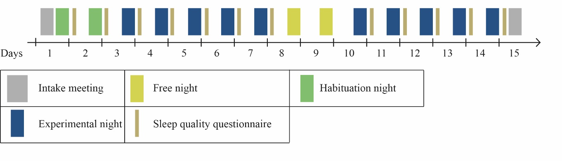

**Voluntary participation**

There are no consequences if you decide now not to participate in this study. During the experiment, you are free to stop participating at any moment without giving a reason for doing so. If you decide to do this, you will receive compensation corresponding to the time that you participated until resignation. Within seven days after participation, you are allowed to withdraw your data from this research and your data will be deleted permanently.

**Epileptic activity**

There is a very small chance that the EEG study will give indications for the existence of epileptic activity. In this case we would inform your general practitioner (GP). In case you do not agree with that, you cannot participate in this study. If you agree we will ask you to provide your GP’s contact details. We would also like to inform you that the investigators are not qualified to detect epileptic activity. If we detect unusual activity in your EEG that causes us to inform you and your general practitioner, this does not mean that you actually have epilepsy. For a diagnosis you would need to consult with your GP.

**Discomfort, risks and insurance**

As with any research at the University of Amsterdam, a standard liability insurance applies.

**Your privacy is guaranteed**

Your personal information (about who you are) will be anonymized and will not be shared without your explicit consent. Personal information collected only for screening (such as provided in the Declaration of Compliance) will be safely disposed of after completing the experiment. Your research data will be anonymized and analyzed by the researchers that collected the information. Research data published in scientific journals will be anonymous and cannot be traced back to you as an individual. Completely anonymized data can be shared with other researchers.

**Compensation**

As compensation for your participation, you will receive 19 research credits:

* 0.5 research credits for the intake meeting;
* 18 credits for the recording nights (1.5 credits per night)
* 0.5 research credits for the final meeting.

Early termination of the study will result in research credits rewarded for the number of experiment days up to the moment of termination.

**Further information**

Should you have questions about this study at any given moment, please contact the responsible researchers: S. L. Jongejan (tel.: 06-81869983; e-mail: S.L.Jongejan@uva.nl); Dr. L. M. Talamini (tel.: 020-5256840; e-mail: L.M.Talamini@uva.nl; room 0.08, REC G Nieuwe Achtergracht 129, 1018WS, Amsterdam); K. Z. Kołodziejczyk (tel.: 06-18698936, e-mail: kat.kolodziejczyk@student.uva.nl); S. J. de Vries (tel.: 06-18977317; e-mail: sebas.devries@student.uva.nl); M. L. Trajdos (tel.: 06-87404424; e-mail: m.l.trajdos@student.vu.nl). Formal complaints about this study can be addressed to the Ethical Review Board of the psychology Brain & Cognition department of the University of Amsterdam, Mr. Dr. Y. (Yaïr) Pinto (tel.: 020-5256847; e-mail: Y.Pinto@uva.nl, room 0.07, REC G Nieuwe Achtergracht 129, 1018WS, Amsterdam).

Thank you,

Stefan L. Jongejan

Lucia M. Talamini

Katarzyna Kołodziejczyk

Sebastiaan de Vries

Michał Trajdos